NAME : SHYAM SUNDAR K
REG NO. 241801268
EXP NO: 8
4. Find the highest, lowest, sum, and average salary of all employees. Label the columns Maximum, Minimum, Sum, and Average, respectively. Round your results to the nearest whole number
SELECT
ROUND(MAX(salary)) AS Maximum,
ROUND(MIN(salary)) AS Minimum,
ROUND(SUM(salary)) AS Sum,
ROUND(AVG(salary)) AS Average
FROM EMPLOYEES1;
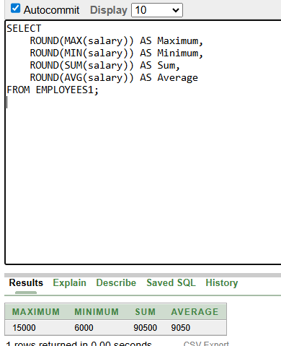

5 Modify the above query to display the minimum, maximum, sum, and average salary for each job type.
SELECT
job_id,
ROUND(MIN(salary)) AS Minimum,
ROUND(MAX(salary)) AS Maximum,
ROUND(SUM(salary)) AS Sum,
ROUND(AVG(salary)) AS Average
FROM EMPLOYEES1
GROUP BY job_id;
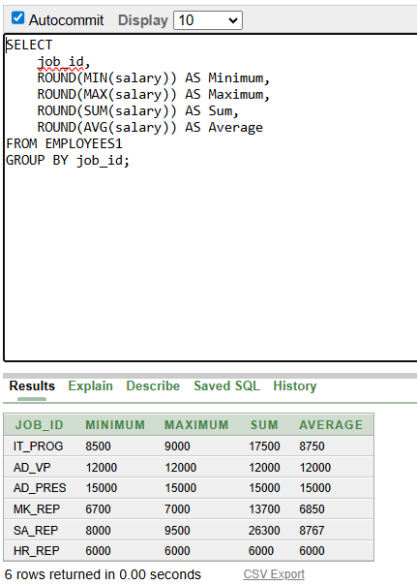

6.Write a query to display the number of people with the same job. Generalize the query so that the user in the HR department is prompted for a job title.
SELECT job_id, COUNT(*) AS Number_of_Employees
FROM EMPLOYEES1
WHERE job_id = :job_title
GROUP BY job_id;
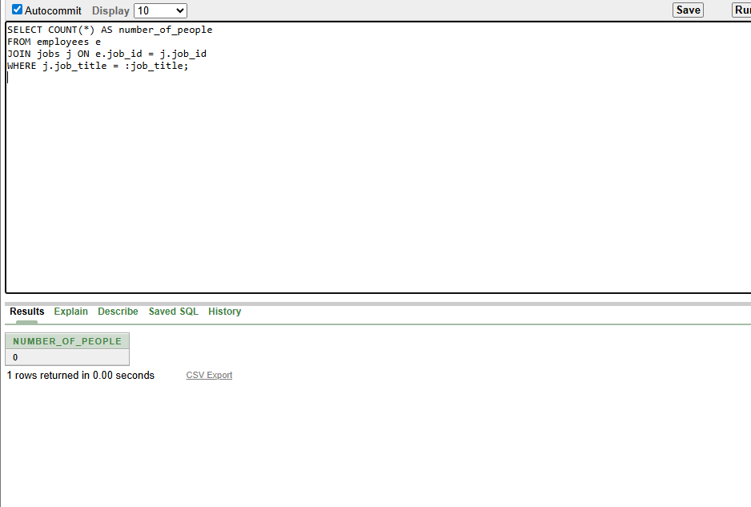

7. Determine the number of managers without listing them. Label the column Number of Managers. Hint: Use the MANAGER_ID column to determine the number of managers.
SELECT COUNT(DISTINCT manager_id) AS Number_of_Managers
FROM EMPLOYEES1
WHERE manager_id IS NOT NULL;
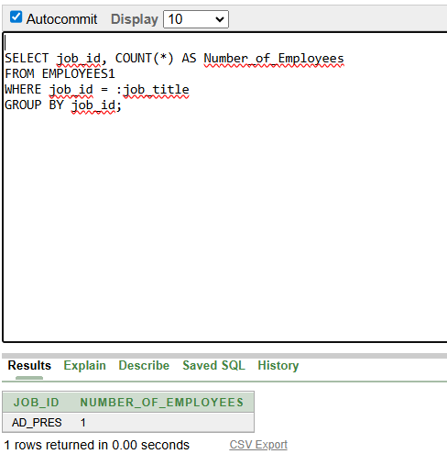

8 Find the difference between the highest and lowest salaries. Label the column DIFFERENCE.
SELECT (MAX(salary) - MIN(salary)) AS DIFFERENCE
FROM EMPLOYEES1;
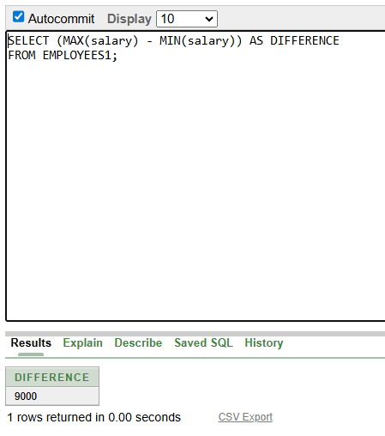

9. Create a report to display the manager number and the salary of the lowest-paid employee for that manager. Exclude anyone whose manager is not known. Exclude any groups where the minimum salary is $6,000 or less. Sort the output in descending order of salary.
SELECT manager_id, MIN(salary) AS lowest_salary
FROM employees5
WHERE manager_id IS NOT NULL
GROUP BY manager_id
HAVING MIN(salary) > 6000
ORDER BY lowest_salary DESC;
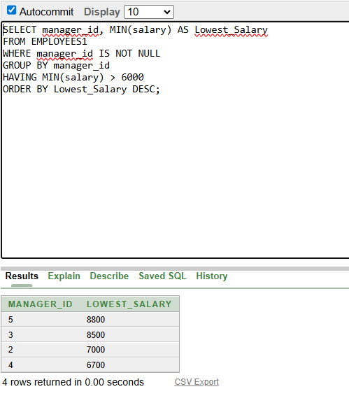
10. Create a query to display the total number of employees and, of that total, the number of employees hired in 1995, 1996, 1997, and 1998. Create appropriate column headings.
SELECT
COUNT(*) AS Total_Employees,
SUM(CASE WHEN EXTRACT(YEAR FROM hire_date) = 1995 THEN 1 ELSE 0 END) AS Hired_1995,
SUM(CASE WHEN EXTRACT(YEAR FROM hire_date) = 1996 THEN 1 ELSE 0 END) AS Hired_1996,
SUM(CASE WHEN EXTRACT(YEAR FROM hire_date) = 1997 THEN 1 ELSE 0 END) AS Hired_1997,
SUM(CASE WHEN EXTRACT(YEAR FROM hire_date) = 1998 THEN 1 ELSE 0 END) AS Hired_1998
FROM EMPLOYEES1;
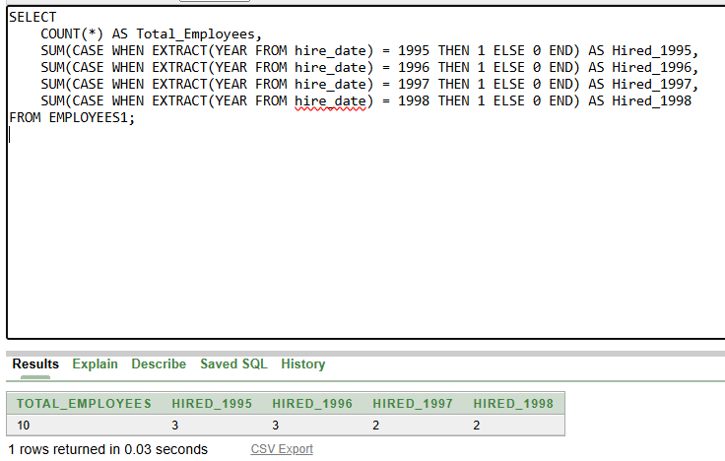

11. Create a matrix query to display the job, the salary for that job based on department number, and the total salary for that job, for departments 20, 50, 80, and 90, giving each column an appropriate heading.
SELECT
job_id,
SUM(CASE WHEN department_id = 20 THEN salary ELSE 0 END) AS Dept_20_Salary,
SUM(CASE WHEN department_id = 50 THEN salary ELSE 0 END) AS Dept_50_Salary,
SUM(CASE WHEN department_id = 80 THEN salary ELSE 0 END) AS Dept_80_Salary,
SUM(CASE WHEN department_id = 90 THEN salary ELSE 0 END) AS Dept_90_Salary,
SUM(salary) AS Total_Salary
FROM EMPLOYEES1
WHERE department_id IN (20, 50, 80, 90)
GROUP BY job_id;

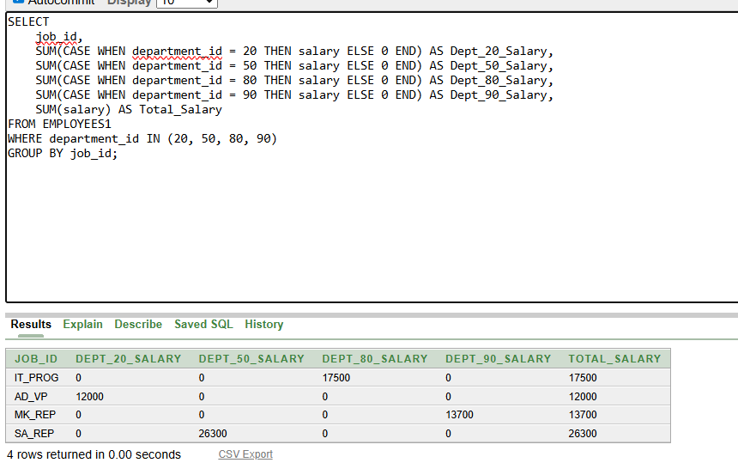
12.Write a query to display each department’s name, location, number of employees, and the average salary for all the employees in that department. Label the column name-Location, Number of people, and salary respectively. Round the average salary to two decimal places.
SELECT
d.department_name || '-' || l.city AS "Name-Location",
COUNT(e.employee_id) AS "Number of people",
ROUND(AVG(e.salary), 2) AS Salary
FROM DEPARTMENT d
JOIN LOCATIONS l ON d.location_id = l.location_id
LEFT JOIN EMPLOYEES1 e ON d.department_id = e.department_id
GROUP BY d.department_name, l.city;
